Nama : Kasih Pratama
Nim : 109102500009

Soal 1 Stack menggunakan Array
Fitur: Push, Pop, PrintInfo, dan BalikStack. Kapasitas maksimal 20 elemen.
Simpan dengan nama soal1.cpp.
Codingan nya :
#include <iostream>
using namespace std;

const int MAX_STACK = 20;

struct Stack {
int info[21];
int Top;
};

void createStack(Stack &S) {
S.Top = 0;
}

bool isEmpty(const Stack &S) {
return S.Top == 0;
}

bool isFull(const Stack &S) {
return S.Top == MAX_STACK;
}

bool push(Stack &S, int x) {
if (isFull(S)) {
return false;
}

S.Top++;
S.info[S.Top] = x;
return true;
}

bool pop(Stack &S, int &x) {
if (isEmpty(S)) {
return false;
}

x = S.info[S.Top];
S.Top--;
return true;
}

void printInfo(const Stack &S) {
if (isEmpty(S)) {
cout << "Stack kosong.\n";
return;
}

cout << "Isi stack dari TOP ke bawah: ";

for (int i = S.Top; i >= 1; i--) {
cout << S.info[i] << " ";
}

cout << endl;
}

void balikStack(Stack &S) {
Stack bantu;
createStack(bantu);

int nilai;

while (pop(S, nilai)) {
push(bantu, nilai);
}

while (pop(bantu, nilai)) {
push(S, nilai);
}
}

int main() {
Stack S;
createStack(S);

int pilihan, nilai;

do {
cout << "\n===== MENU STACK ARRAY =====\n";
cout << "1. Push\n";
cout << "2. Pop\n";
cout << "3. Tampilkan\n";
cout << "4. Balik Stack\n";
cout << "5. Keluar\n";
cout << "Pilihan: ";
cin >> pilihan;

switch (pilihan) {
case 1:
cout << "Masukkan bilangan: ";
cin >> nilai;

if (push(S, nilai)) {
cout << nilai << " berhasil ditambahkan.\n";
} else {
cout << "Stack sudah penuh.\n";
}
break;

case 2:
if (pop(S, nilai)) {
cout << "Nilai yang di-Pop: " << nilai << endl;
} else {
cout << "Stack kosong.\n";
}
break;

case 3:
printInfo(S);
break;

case 4:
balikStack(S);
cout << "Stack berhasil dibalik.\n";
printInfo(S);
break;

case 5:
cout << "Program selesai.\n";
break;

default:
cout << "Pilihan tidak valid.\n";
}

} while (pilihan != 5);

return 0;
}

Output :
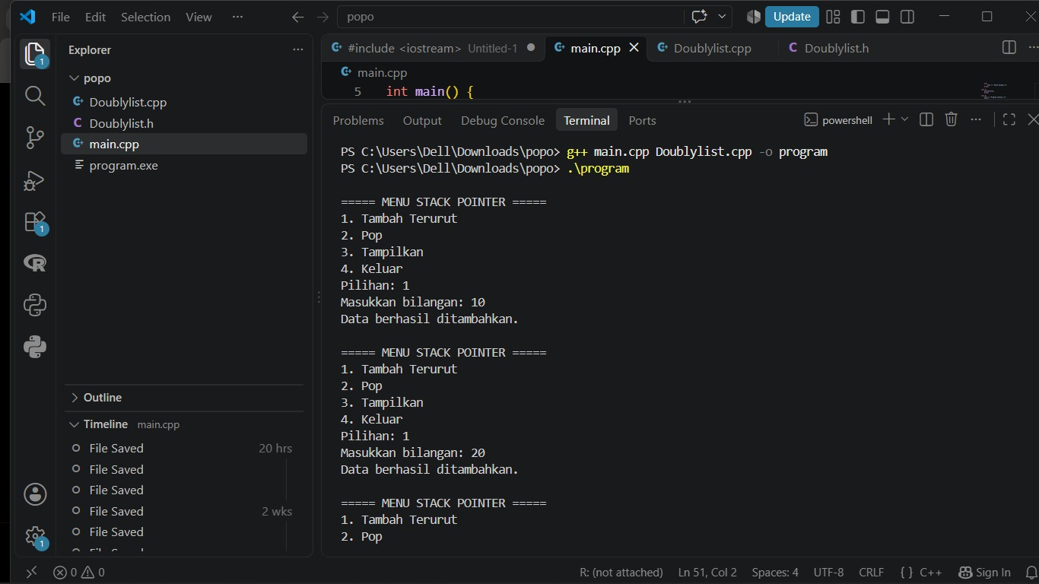
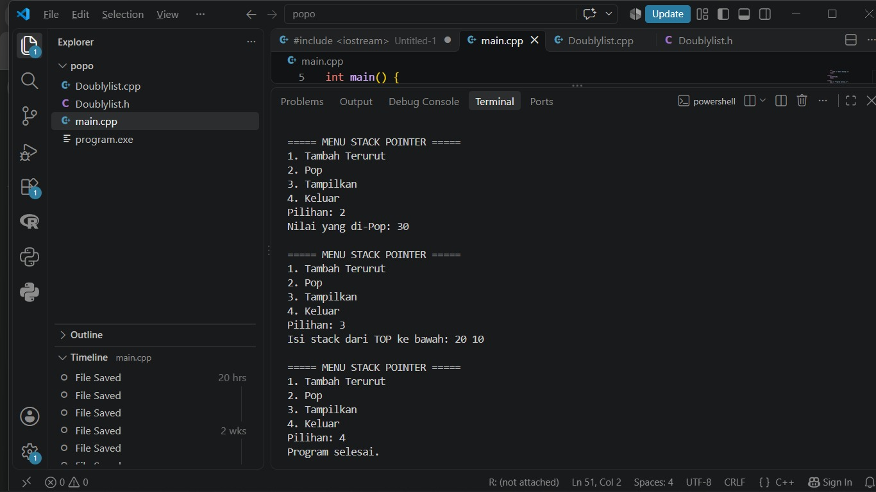

Soal 2 – Stack menggunakan Pointer
Fitur: Push, Pop, PrintInfo, dan pushAscending untuk memasukkan angka secara terurut.
Simpan dengan nama soal2.cpp.
Codingan :
#include <iostream>
#include "Doublylist.h"
using namespace std;

void createStack(Stack &S) {
S.Top = nullptr;
}

bool isEmpty(const Stack &S) {
return S.Top == nullptr;
}

Node* alokasi(int x) {
Node *P = new Node;
P->info = x;
P->next = nullptr;
return P;
}

void dealokasi(Node *P) {
delete P;
}

bool push(Stack &S, int x) {
Node *P = alokasi(x);

if (P == nullptr) return false;

P->next = S.Top;
S.Top = P;
return true;
}

bool pop(Stack &S, int &x) {
if (isEmpty(S)) return false;

Node *P = S.Top;
x = P->info;
S.Top = P->next;
dealokasi(P);

return true;
}

void printInfo(const Stack &S) {
Node *P = S.Top;

if (P == nullptr) {
cout << "Stack kosong.\n";
return;
}

cout << "Isi stack dari TOP ke bawah: ";

while (P != nullptr) {
cout << P->info << " ";
P = P->next;
}

cout << endl;
}

void clearStack(Stack &S) {
int nilai;

while (pop(S, nilai)) {
}
}

void pushAscending(Stack &S, int x) {
Stack bantu;
createStack(bantu);

int nilai;

while (!isEmpty(S) && S.Top->info > x) {
pop(S, nilai);
push(bantu, nilai);
}

push(S, x);

while (pop(bantu, nilai)) {
push(S, nilai);
}
}

Output :


